Special Educational Needs and Disabilities (SEND) Information Report
St.Peter’s CE Primary School


Inclusion Team SEND Governor: Mrs Pamela Lock

SENCO:
Mrs Vicky Jenner

Contact No: 01892 525727 Contact email: senco@st-peters.kent.sch.uk

Approved by: | Headteacher and Governors | Date: Spring 2026
Last reviewed on: | SEND Policy last reviewed Spring 2026
Next review due by: | Spring 2027

Contents
- What types of SEND does the school provide for? 4
- Which staff will support my child? 5
- What should I do if I think my child has SEND? 7
- What happens if the school identifies a need? 8
- How will the school measure my child’s progress? 9
- How will I be involved in decisions made about my child’s education? 10
- How will my child be involved in decisions made about their education? 10
- How will the school adapt its teaching for my child? 11
- How will the school evaluate whether the support in place is helping my child? 12
- How will the school ensure my child has appropriate resources? 13
- How will the school make sure my child is included in activities alongside pupils who don’t have
SEND? 14
- How does the school make sure the admissions process is fair for pupils with SEN or a disability?
. 14
- How does the school support pupils with disabilities? 15
- How will the school support my child’s mental health and emotional and social development?
. 16
- What support is in place for looked-after and previously looked-after children with SEN? 17
- What support will be available for my child as they transition between classes or settings or in preparing for adulthood? 17
- What support is available for me and my family? (Local Offer) 18
- What should I do if I have a complaint about my child’s SEND support? 18
- Supporting Documents 19
- Glossary 20

Dear parents and carers,
The aim of this Information Report is to explain how we implement our SEND policy. In other words, we want to show you how SEND support works in our school.
As educational professionals, we are all working towards the ultimate goal of growing independent young people as they prepare for adulthood. All provision and support we provide is working towards achieving the Kent Children and Young People (CYP) Outcomes Framework:
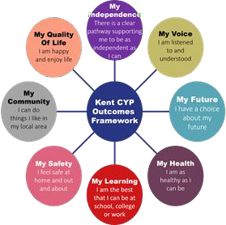

If you want to know more about our arrangements for SEND, read our SEND policy alongside this Information Report.
You can find our SEND policy on our website https://www.st-peters.kent.sch.uk/attachments/download.asp?file=819&type=pdf
Note: If there are any terms we’ve used in this information report that you’re unsure of, you can look
them up in the Glossary at the end of the report.

What types of SEND does the school provide for?
Our school provides for pupils with the following needs (as outlined in the SEND Code of Practice 2015):

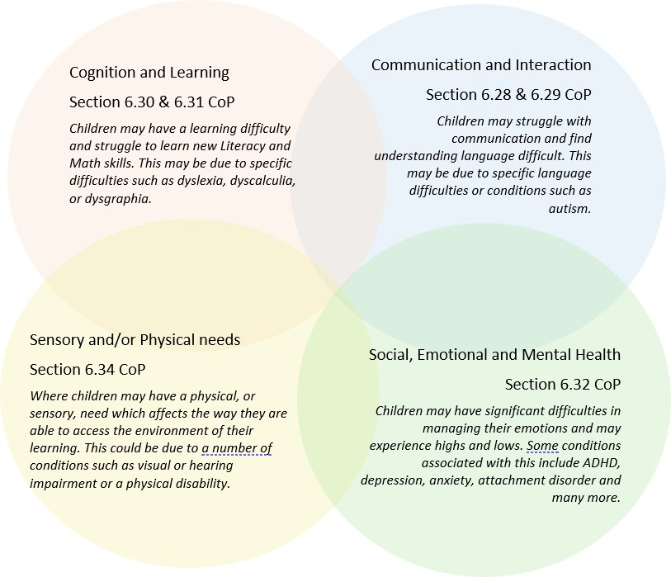

Often you will find that children’s needs overlap and are rarely confined to one area of need, which is why it is important to gain a holistic overview of your child.
More information about the Areas of Need can be found in the Special educational needs and disability code of practice: 0 to 25 years (link below).
SEND_Code_of_Practice_January_2015.pdf (publishing.service.gov.uk)

2. Which staff will support my child, and what are their key responsibilities?


At St.Peter’s CE Primary School, all staff are considered responsible for supporting the needs of pupils with SEND. Our staff are committed to regular, high-quality training to ensure that they have the knowledge and skills to better meet a wide range of pupil needs.
Below outlines key staff who will be supporting your child. Please note that this list is not exhaustive.

Our Special Educational Needs Co-ordinator, or SENCO
The named SENCO is Vicky Jenner.
She is a qualified teacher and has been working at St.Peter’s CE Primary School since 2007. She
achieved the National Award in Special Educational Needs Co-ordination in 2020.

Class/subject teachers All of our teachers receive in-house SEN training, and are supported by the SENCO to meet the needs of pupils who have SEN.
This has included recent training on:
- Mainstream Core Standards
- AET Making sense of Autism
- Colourful Semantics
- Zones of Regulation
- Nurture, trauma and attachment, and Boxall profiles
- Autism, ADHD and declarative language
Teaching assistants (TAs) We have an excellent TA team, including number teaching assistants who are trained to deliver SEN provision.
This has included recent training on:
- Mainstream Core Standards
- AET Making sense of Autism

- Colourful Semantics
- Zones of Regulation
- Nurture, trauma and attachment and Boxall profiles
- Sensory Circuits
- Autism, ADHD and declarative language
We have a number of teaching assistants who are trained to deliver interventions such as: Little Wandle Phonics Keep-up and Catch-up interventions, Speech and Language Link, Lego Therapy, Maths and English support, BEAM and Sensory Circuits.
We have a pastoral Teaching Assistant who is trained to run a Talking and Drawing intervention and is an ELSA. We also have a Teacher who is involved in leading the Nurture UK programme with the SENCo.
External agencies Sometimes we need extra help to offer our pupils the support that they need. Whenever necessary we will work with external support services to meet the needs of our pupils with SEND and to
support their families. These may include:

- Child and adolescent mental health services (CAMHS)
- Education welfare officers

- Educational psychologists
- Speech and language therapists
- Voluntary sector organisations


- GPs or paediatricians
- Occupational therapists
- Emotions coaches
- Safeguarding services
- School Liaison Officer
- School nurses
- SEND Inclusion Advisor
- Specialist Teacher Service

What should I do if I think my child has SEND?
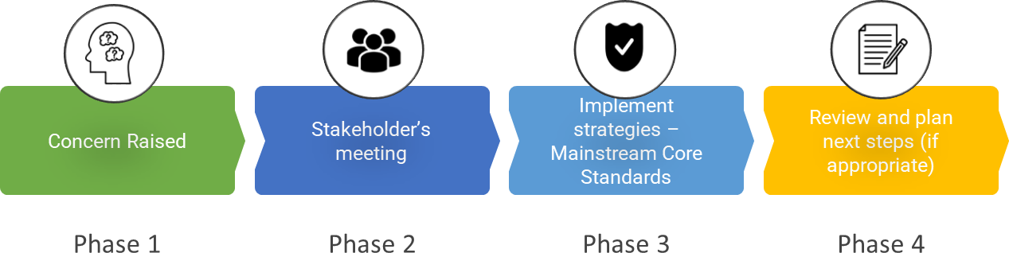

Phase 1 | If you think your child might have SEND, raise your concern with the school so that the SENCO is aware.  Parents can contact their child’s class teacher by contacting the office on 01892 525727 or emailing admin@st-peters.kent.sch.uk. Our school SENCO is available on 01892 525727 or by emailing senco@st-peters.kent.sch.uk.
Phase 2 | We will meet with you to discuss your concerns and try to get a better understanding of what your child’s strengths and difficulties are. Together we will decide what outcomes to seek for your child and agree on next steps.  We will make a note of what’s been discussed and add this to your child’s  record.
Phase 3 | We will implement the agreed strategies and monitor these over an agreed period of time. These are likely to be universal strategies set out in the mainstream core standards. A copy of this can be found here: https://www.kelsi.org.uk/ data/assets/pdf_file/0005/117257/Special-educational-needs-mainstream-core-standards-guide-for-parents.pdf.  This will initiate the ‘Graduated Approach’ where support will be  continually reviewed. See next page for more details.
Phase 4 | After a period of using different strategies and support, if we decide that your child needs SEND support, we will formally notify you and your child will be added to the school’s SEND register.  They will receive additional support, and this will be reviewed using the assess, plan, do, review model.

St Peters’ CE Primary School SEND Report 2026 Page 7 of

What happens if the school identifies a need?
The same process is followed if a concern is raised by the school.

All our class teachers are responsible for the monitoring of all pupils who have been identified as having SEND. At St.Peter’s CE Primary School, we monitor the progress of all pupils six three times a year at Pupil Progress meetings. Children’s wellbeing is critical to their progress and attainment so at Pupil Progress meetings, Class teachers, Head Teacher, Deputy Head Teacher, Senior Teacher and SENCo review both the wellbeing and academic progress of the pupils in their class.
If the teacher notices that a pupil is having difficulties, they try to find out if the pupil has any gaps in their learning. If they can find a gap, the school will provide appropriate support. Pupils who don’t have SEND usually make progress quickly once the gap in their learning has been filled.
If the pupil is still finding it difficult to make the expected progress, the teacher will talk to the SENCO, and will contact you to discuss the possibility that your child has SEND, and the school will follow the graduated approach (see previous page).

How will the school measure my child’s progress?
We will follow the ‘graduated approach’ to meeting your child’s SEND needs. The graduated approach is a 4-part cycle of assess, plan, do, review.
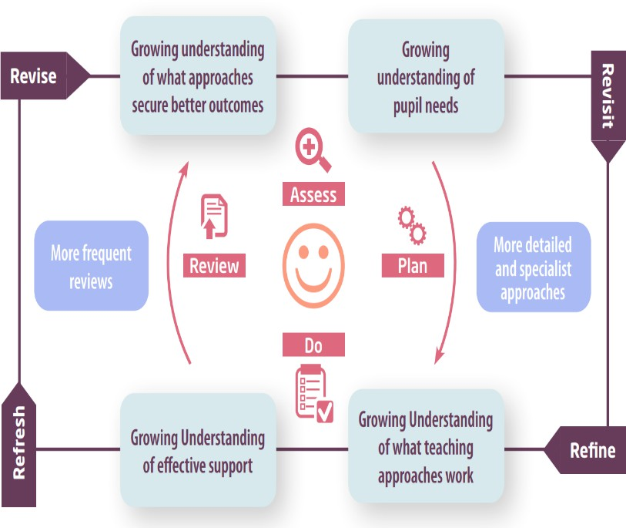

Assess | If your child is not making the expected level of progress, we will make an assessment to find out what strengths and difficulties your child has. We will ask for you and your  child’s input, as well as getting help from external professionals where necessary.
Plan | In discussion with you and your child, we will decide what outcomes we are hoping to achieve. We will make a plan of the support we will offer your child to help them meet those outcomes. We will make a record of this and share it with you and all relevant school staff.
Do | We will put our plan into practice.  The class teacher, with the support of the SENCO, will be responsible for working with your child on a daily basis, and making sure the support we put in place is having the impact we intended.
Review | We will assess how well the support we put in place helped the pupil to meet the outcomes we set. We will use our improved understanding of your child’s needs to improve the support we offer; this may mean the Plan, Assess, Do, Review cycle continues.

How will I be involved in decisions made about my child’s education?
We will provide a termly report on your child's progress.
In addition to this, a SEND Consultation will take place 3 times a year with the SENCO and class teachers. The final SEND Consultation will be with the SENCo, current class teacher and new class teacher. The purpose of these meetings is to:
  - Set clear outcomes for your child’s progress
  - Review progress towards those outcomes
  - Discuss the support we will put in place to help your child make that progress
  - Identify what we will do, what we will ask you to do, and what we will ask your child to do
We know that you’re the expert when it comes to your child’s needs and aspirations. So, we want to make sure you have a full understanding of how we’re trying to meet your child’s needs, so that you can provide insight into what you think would work best for your child.
We also want to hear from you as much as possible so that we can build a better picture of how the SEND support we are providing is impacting your child outside of school. If your child’s needs or aspirations change at any time, please let us know right away so we can keep our provision as relevant as possible.
If you have concerns that arise between these meetings, please contact your child’s class teacher or
SENCo. Our school SENCO is available on 01892 525727 or senco@st-peters.kent.sch.uk.
- How will my child be involved in decisions made about their education? The level of involvement will depend on your child’s age and individual needs. We recognise that no two pupils are the same, so we will decide on a case-by-case basis, with your input.
We may seek your child’s views by asking them to:
  - Attend meetings to discuss their progress and outcomes
  - Prepare a presentation, written statement, video, drawing, etc.
  - Discuss their views with a member of staff who can act as a representative during the meeting
  - Complete a survey

How will the school adapt its teaching for my child?
Your child’s teacher is responsible and accountable for the progress and development of all the pupils in their class.
High-quality teaching is our first step in responding to your child’s needs. We will make sure that your
child has access to a broad and balanced curriculum in every year they are at our school.
We will adapt our approaches to how we teach to suit the way the pupil works best. There is no 'one size fits all’ approach to adapting the curriculum, we work on a case-by case basis to make sure the adaptations we make are meaningful to your child and are guided by the Mainstream Core Standards in the first instance.
These adaptations may include:
Adapting our approaches, for example, giving longer processing times, pre-teaching of key vocabulary, copies of the slides in front of them, reading instructions aloud, etc.


Adapting our resources and staffing.



Using recommended aids, such as laptops, coloured overlays, visual timetables, larger font, etc.

Teaching assistants or support staff will support pupils appropriately depending on their presentation of need



Scaffolding lesson materials

Our Accessibility Plan is in place which increases the extent to which disabled pupils can participate in the curriculum. The link is as follows: https://www.stpeters.kent.sch.uk/attachments/download.asp?file=865&type=pdf

We may also provide interventions, some examples of which are:

Interventions in place to support children
Cognition and Learning | Communication and Interaction | Social, Emotional and Mental Health | Physical/Sensory
Little Wandle Phonics Catch-up and Keep-up | Lego Therapy | Play Therapy | Sensory Circuits
Maths Catch-up and Keep-up | Language Link | Emotion Coaching | BEAM
Timetables Catch-up and Keep-up | Speech Link | ELSA | Clever fingers
1:1 personalised Maths or Literacy support, including grammar and spelling | Colourful Semantics | Talking and Drawing | Sensory/movement breaks
Colourful Semantics |  | Zones of Regulation
Maths and English pre-teach |  | Time with Therapy Dog

These interventions are part of our contribution to Kent County Council’s local offer.
9. How will the school evaluate whether the support in place is helping my child?
We will evaluate the effectiveness of provision for your child by:
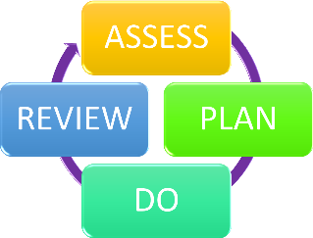
Reviewing their progress towards their goals each term
Reviewing the impact of interventions after an appropriate number of weeks; normally 6 or 12 in line with each term
Using pupil questionnaires
Monitoring by the SENCO
Using class provision maps or personalised plans to measure progress

Holding an annual review (if they have an education, health and care (EHC) plan)
- How will the school ensure my child has appropriate resources? As part of our budget, we receive ‘notional SEND funding’. This funding is used to ensure that the quality of teaching is good in the school and that there are sufficient resources to deploy additional and different teaching for pupils requiring SEND support. The amount of support required for each
pupil to make good progress will be different in each case.
In very few cases, a higher level of resource is required. If there are groups of children (or in exceptional cases 1 child) who need: additional funding for resources to help their learning, further training for our staff, or additional intervention, a request for funding can be made to our ‘Community of Schools’ which may or may not be agreed. This is a group of schools who have an allocated amount of funds to spend across the schools over the academic year.
Where appropriate, we will consult with external agencies to get recommendations on what will best help your child access their learning and use our best endeavours to ensure these are supplied.


11. How will the school make sure my child is included in activities alongside pupils
who don’t have SEND?
The expectation is that all schools provide an inclusive provision for all pupils. It may be necessary for some pupils to receive interventions in addition to a broad and balanced curriculum.
As much as possible, all of our extra-curricular activities and school visits are available to all our pupils, including our before and after-school clubs.
All pupils are encouraged to go on our school trips, including our residential trip.
All pupils are encouraged to take part in sports day, school plays and special workshops.
No pupil is ever excluded from taking part in these activities because of their SEN or disability and we will make whatever reasonable adjustments are needed to make sure that they can be included. All clubs, trips and activities offered to pupils at St.Peter’s CE Primary School are available to pupils with special educational needs either with or without an Education, Health and Care Plan. Where it is necessary, the school will use the resources available to it to provide additional adult support to enable the safe participation of the pupil in the activity.
12. How does the school make sure the admissions process is fair for pupils with SEN or a disability?
All children are welcome to apply to St.Peter’s CE Primary School. If you are the parent of a child with additional needs and are considering applying for a place, you may wish to contact the SENCo to discuss his/her needs and how they could be met. Parents of children with known additional needs will be invited to meet with the SENCo prior to their child starting at St.Peter’s CE Primary School in order that the school has a good understanding of the child’s needs and can ensure appropriate support and provision is in place. If appropriate, introductory visits or part-time arrangements will be made for children with complex needs. The SENCo and EYFS/Year 6 Team liaises with colleagues in nurseries, pre-school settings and secondary schools to ensure appropriate transition arrangements are in place. Year Six teachers plan lessons during the summer term to prepare children for secondary school. Visits to local secondary schools are arranged for children who will be transferring to them. In addition, there are clear transition arrangements made at the end of each academic year for individual pupils to ensure a smooth handover. Where necessary, additional transition opportunities are provided for vulnerable pupils, supported by members of school staff as appropriate
When a year group is oversubscribed, the admissions criteria are administered in line with Kent County Council guidance, which can be found on KCC’s website and linked for ease of access here. In line with Kent’s policy, the order in which children are assessed for admission is listed below:
  - children in Local Authority care or previously in Local Authority care
  - children with an EHCP in place
  - attendance at a linked school (only relevant to infant and Junior schools where they are linked) - current family association (sibling)
  - health, social and special access – medical reasons
  - nearness of children’s homes to school

How does the school support pupils with disabilities?

You’re disabled under the Equality Act 2010 if you have a physical or mental impairment that has a ‘substantial’ and ‘long-term’ negative effect on your ability to do normal daily activities.
As stated by the 2010 Equality Act, schools have a duty to make reasonable adjustments for disabled children. For schools, the duty is summarised as follows:
Where something a school does potentially places a disabled pupil at a disadvantage compared to other pupils then the school must take reasonable steps to try and avoid that disadvantage. Schools will be expected to provide an auxiliary aid or service for a disabled pupil when it would be reasonable to do so and if such an aid would alleviate any substantial disadvantage that the pupil faces in comparison to non-disabled pupils.
At St.Peter’s CE Primary School, we include all children in all the learning that takes place, including outdoor learning and school trips. Children with additional needs may need special consideration to ensure that they can participate, for example by ensuring that 1:1 support is available for a child with complex needs or visual impairment. Parents are often invited to join school trips to provide an appropriate level of supervision and ensure the safety and wellbeing of all. Our school environment is a new building that has been designed to suit the needs of all pupils with wide corridors, disabled toilets and parking, colour contrast on stair edges and door frames and brailled labelling around the school.
Please find more information on our Accessibility Plan. The link is as follows: https://www.st-peters.kent.sch.uk/attachments/download.asp?file=865&type=pdf

14. How will the school support my child’s mental health and emotional and social development?
We prioritise children’s mental health and emotional and social development in everything that we do. The SENCo and one Teaching Assistant are currently leading the Nurture Programme to become a Nurture School. We have a highly trained pastoral team including the school SENCo, Play Therapist, Talking and Drawing Practitioner and ELSA, and therapy dog who provide our wellbeing support.
We provide support for pupils to progress in their emotional and social development in the following ways:
  - By developing emotional and social skills, both through teaching PSHE lessons where every year group follows SCARF (Safety, Caring, Achievement, Resilience and Friendship) scheme and assemblies
  - Pupils with SEND are encouraged to be part of School Council and other roles and responsibilities in school
  - Pupils with SEND are also encouraged to attend a variety of clubs to promote teamwork/building friendships
  - We provide extra pastoral support for listening to children with SEND through 1:1 check-ins or
‘walk and talk’ with the SENCo, ELSA or a Teaching Assistant.
  - In addition to 1:1 sessions with our pastoral support (Play Therapist, Talking and Drawing Practitioner, ELSA or Therapy Dog), we run a nurture interventions for pupils who need extra support with social or emotional development. These interventions are personalised according to the needs of the child.
  - We put in place nurture support over lunchtime to support different children’s needs.
  - We have a ‘zero tolerance’ approach to bullying. Our anti-bullying policy can be found here: https://www.st-peters.kent.sch.uk/attachments/download.asp?file=719&type=pdf
  - Assessment using Boxall Profile. Pupils in the early stages of emotional and social development because of their special educational needs will be supported through our pastoral team and SEN team as appropriate. External referrals can also be made and supported by the school if additional support is required.

15. What support is in place for looked-after and previously looked-after children with SEND?


Vicky Jenner is the designated teacher for looked after children and previously looked-after children here. She will make sure that all teachers understand how a looked-after or previously looked-after pupil’s circumstances and their SEND might interact, and what the implications are for teaching and learning.
Pupils who are looked-after or previously looked-after will be supported much in the same way as any other child who has SEND. However, looked-after pupils will also have a personal education plan (PEP). We will make sure that the PEP and any SEND support plans or EHC plans are consistent and complement one another. It is a legal requirement for every young person in care of statutory school age to have their PEP reviewed at least three times each academic year.
16. What support will be available for my child as they transition between classes or settings or in preparing for adulthood?

Between years
To help pupils with SEND be prepared for a new school year we:

Arrange transition sessions in the Summer Term where they meet their new teachers and see their new classroom environment.
For pupils on the SEN register, the summer SEND Consultations involve both current and future staff. Current support is described, and future support is discussed.

Between schools
We contribute information to a pupils’ onward destination by providing information to the next setting.

Between phases
Where appropriate, our SENCo meets/speaks to the SENCos at pre-schools and Early Years teaching staff arrange additional visits to pre-schools to get to know children to support their transition. Our Little P’s ‘Play and Stay’ session for toddlers and pre-schoolers supports children to get to know our school building and staff before they start school.
The SENCO of the secondary school will meet/speak to our SENCo. They will discuss the needs of all the pupils who are receiving SEND support.


Pupils will be prepared for the transition by:
  - A series of lessons for all Year 6 children to focus on secondary skills e.g. practising with a secondary school timetable, learning how to get organised independently
  - Bespoke transition groups run by our pastoral team to support children who may need additional practical or emotional support with the transition.

What support is available for me and my family?
If you have questions about SEND, or are struggling to cope, please get in touch to let us know. We want to support you, your child and your family.
To see what support is available to you locally, have a look at Kent’s local offer. Kent publishes information about the local offer on their website: https://www.kent.gov.uk/education-and-children/special-educational-needs
Our local special educational needs and disabilities information advice and support services (SENDIASS) organisations are: https://www.iask.org.uk/
In addition, Kent PACT (Parent and Carer Together) is a parent carer forum set up for parents of children and young adults with disabilities and additional needs. They offer a way for you to have your say and influence us, local health services and other organisations in improving local services. Some of the parents on the forum are also key members of the joint KCC/NHS SEND Improvement Board.
https://kentpactnew2022.co.uk/
NHS Kent Community Therapy Services provides a wealth of information online which includes supporting videos and advice to both parents and schools. This can be accessed via the link below:
https://www.kentcht.nhs.uk/childrens-therapies-the-pod/
Local charities that offer information and support to families of pupils with SEND are: Space 2 Be Me
- Making a difference to the lives of disabled children and their families
National charities that offer information and support to families of pupils with SEND are:
  - IPSEA
  - SEND family support
  - NSPCC
  - Family Action
  - Special Needs Jungle

What should I do if I have a complaint about my child’s SEND support?
The normal arrangements for the treatment of complaints at St.Peter’s CEP School are used for complaints about provision made for special educational needs. You can find our complaints policy here:

https://www.st-peters.kent.sch.uk/attachments/download.asp?file=872&type=pdf
Complaints about SEND provision in our school should be made to the class teacher, SENCO or headteacher in the first instance. They will then be referred to the school’s complaints policy.
If you are not satisfied with the school’s response, you can escalate the complaint. In some
circumstances, this right also applies to the pupil themselves.
To see a full explanation of suitable avenues for complaint, see pages 246 and 247 of the SEND Code of Practice.
If you feel that our school discriminated against your child because of their SEND, you have the right to make a discrimination claim to the first-tier SEND tribunal. To find out how to make such a claim, you should visit: https://www.gov.uk/complain-about-school/disability-discrimination
You can make a claim about alleged discrimination regarding:
- Admission
- Exclusion
- Provision of education and associated services
- Making reasonable adjustments, including the provision of auxiliary aids and services
Before going to a SEND tribunal, you can go through processes called disagreement resolution or mediation, where you try to resolve your disagreement before it reaches the tribunal. Details of the disagreement resolution and mediation services for Kent can be found here:
https://www.kent.gov.uk/ data/assets/pdf_file/0011/6140/KPPS-Disagreement-Resolution-Services.pdf

Supporting documents
  - Equality Information and Objectives Policy

  - Child protection and safeguarding policy
  - Behaviour Policy
  - Accessibility Plan
  - Attendance and punctuality policy
  - SEND policy
  - SEN & Disabilities Code Of Practice 2015
  - Mainstream Core Standards

Glossary
- Access arrangements – special arrangements to allow pupils with SEND to access assessments or exams
- Annual review – an annual meeting to review the provision in a pupil’s EHC plan
- Area of need – the 4 areas of need describe different types of needs a pupil with SEND can have. The 4 areas are communication and interaction; cognition and learning; physical and/or sensory; and social, emotional and mental health needs.
- CAMHS – child and adolescent mental health services
- Differentiation – when teachers adapt how they teach in response to a pupil’s needs
- EHC needs assessment – the needs assessment is the first step on the way to securing an EHC plan. The local authority will do an assessment to decide whether a child needs an EHC plan.
- EHC plan – an education, health and care plan is a legally-binding document that sets out a
child’s needs and the provision that will be put in place to meet their needs.
- First-tier tribunal/SEND tribunal – a court where you can appeal against the local authority’s decisions about EHC needs assessments or plans and against discrimination by a school or local authority due to SEND
- Graduated approach – an approach to providing SEND support in which the school provides support in successive cycles of assessing the pupil’s needs, planning the provision, implementing the plan, and reviewing the impact of the action on the pupil
- Intervention – a short-term, targeted approach to teaching a pupil with a specific outcome in mind
- Local offer – information provided by the local authority which explains what services and support are on offer for pupils with SEND in the local area
- Outcome – target for improvement for pupils with SEND. These targets don't necessarily have to be related to academic attainment
- Reasonable adjustments – changes that the school must make to remove or reduce any
disadvantages caused by a child’s disability
- SENCO – the special educational needs co-ordinator
- SEN – special educational needs
- SEND – special educational needs and disabilities
- SEND Code of Practice – the statutory guidance that schools must follow to support pupils with SEND
- SEND information report – a report that schools must publish on their website, that explains how the school supports pupils with SEND
- SEND support – special educational provision which meets the needs of pupils with SEND
- Transition – when a pupil moves between years, phases, schools or institutions or life stages

